Short Rest

A **short rest** is a period of no less than an hour, in which the character does nothing more strenuous than reading, writing, talking, and binding wounds. At the end of a short rest, a character may expend one or more Hit Dice to restore any lost hit points, up to their maximum number of Hit Dice. For each Hit Die expended, the player rolls the dice (as determined by their class) and adds their Constitu­tion modifier. A player can decide to roll an additional Hit Die after each roll.

Long Rest

A **long rest** is a period of time of at least 8 hours, 6 of which must be spent asleep. The remaining hours can be spent doing light activity like eating or standing watch. If this period is interrupted by strenuous activity for more than an hour, such as walking, fighting, or casting spells, the characters gain no benefit and the time period resets.

After a long rest has been completed, a character regains all lost hit points. The character also regains expended Hit Dice, up to a maximum of half of the character’s total number of them (minimum of 1). For example, a character with 10 hit dice who has expended 8 would regain 5 Hit Dice after a long rest.

A character cannot benefit from more than one long rest in a 24-hour period, and must have at least 1 hit point at the start of the long rest to benefit from it. Any character that does not consume at least 1 Supply suffers a level of fatigue when they finish a long rest, and adventurers are only able to recover from fatigue or strife on a long rest when they have access to a haven (Chapter 5: Exploration in *Trials & Treasures).*

Between Adventures

Though an adventurer is typically defined by the dangers they face, the bulk of their time is often spent traveling, healing, preparing, or simply living. Some spend their time with families, others contribute to the communities that they protect, develop relation­ships, or simply kill time until the excitement begins anew.

Roughing It

There is a difference between bare survival and comfort, and many environmental conditions can make adventurers’ rests less rewarding. If any of the following conditions apply to you during a long rest, you regain half the usual number of hit dice. Should you have any levels of fatigue or strife, neither is reduced upon finishing the long rest.

* Slept in medium or heavy armor other than hide.
* Slept without a bedroll or similar bedding on rocky, wet, or uneven terrain.
* Slept exposed to the elements during inclement weather conditions.
* Slept without warmth in an environment of extreme cold.
* Slept without mosquito netting or similar precautions while in a swampy or otherwise insect-ridden area.

Some adventurers, such as rangers, may have features which allow them to ignore the effects of roughing it.

This period between adventures, called downtime, can represent the passing of a season, a period spent traveling, or the time necessary for an ally or NPC to secure a vital piece of information or permission for the party to travel through guarded lands. Additionally, the mental and physical stress of adventuring often necessitates time off, which can prevent characters from jumping from 1st level to 11th level in a single month! While it is not neces­sary to meticulously describe each and every day that PCs spend in this way, providing key details can help to bring the setting to life, create the feeling of time passing, and foreshadow events to come.

When considering these key details, think about significant life events for the adventurers and their friends or allies—weddings, birthdays, funerals, holidays, festivals or other seasonal events, political trends, or significant events occurring abroad that come as news. Any of these can be used to fore­shadow future plots.

Lifestyle

Some adventurers choose to live lavishly between quests while others are content to rent a room at their favorite drinking establishment. When calculating expenses, see page 347 in Chapter 4: Equipment. A character’s lifestyle (poor, moderate, or rich) impacts some of their downtime activities.

An adventurer’s lifestyle can also impact their interactions with those around them. The Narrator may provide advantage or disadvantage on Intelli­gence, Wisdom, and Charisma checks made against people that perceive a PC to be of a different life­style than themselves, depending upon the circum­stances— an adventurer with a poor lifestyle has a harder time getting along with rich nobles and vice versa.

Downtime Activities

Downtime activities represent specific and intentional activities that a character undertakes to achieve a benefit A character can undertake one downtime activity per week of downtime, although they do not necessarily occur sequentially.

A downtime week consists of 5 days each involving at least 8 hours of engaging in a downtime activity. In most cases, an unfinished week does not count towards progress, but in some situations the Narrator might allow specific days to add to the total. At the end of each downtime period, any check required is made and success or failure is determined. Some downtime activities may require more than 1 week to complete. If a downtime activity mentions a month it assumes 4 weeks.

***Extended Downtime.*** When a party of adven­turers is experiencing a particularly long period of downtime, such as a year or longer, the Narrator may extend the length of the downtime period to 1 month and allow players to roll one check per 4 weeks of downtime activity. A success on an extended downtime check is treated as 4 successful weeks of a downtime activity, a failure is treated as 2 successful weeks, and on a failure by 5 or more the character makes no progress at the downtime activity.

For even longer periods of downtime, the Narrator can extend the downtime to seasons (treating a success as 12 weeks, a failure as 6 weeks, and a failure by 5 or more as 3 weeks), or even years (treating a success as 52 weeks, a failure as 26 weeks, and a failure by 5 or more as 13 weeks).

Characters may wish to work together to complete downtime activities. At the Narrator’s discretion, one character may assist another (as the Help action on page 442). Both characters must spend their down­time on the chosen activity.

Craft

Adventurers with tool proficiencies may use their downtime to create weapons, armor, or other items. The Craft activity can be used to create weapons, armor, tools, clothing, other equipment, or a work of art.

All crafted items require materials. Poor quality items can be made with materials equal to 1/10th the base cost of the item that the character wishes to create. Normal quality work requires materials equal to 1/4th the base cost. If a character wishes to craft a fine item, they must acquire fine mate­rials equal to the item’s base cost. If a character wishes to craft a masterwork item, the materials cost is equal to twice the base cost of the item.

***Special Materials.*** Rarely a smith might happen upon special materials. These materials can only rarely be purchased and must often be found. When attempting to craft using adaman­tine, mithral, or other wondrous materials, increase the DC to craft the item by 2. See the Materials section of Chapter 4: Equipment on pages 322-323 for more details.

***Time Required.*** The time required varies depending upon what a character is attempting to craft, as per Table: Crafting Time. At the end of the required time, the character makes a check based upon the desired quality level. On a success, the materials are consumed and they create the item. On a failure, they create an item of one quality level lower than they desired or may salvage the materials. When a character fails by 5 or more, they produce a poor quality item and the materials are consumed.

Chapter 7: Adventuring

|  |  |  |  |  |  |  |
| --- | --- | --- | --- | --- | --- | --- |
| **QUALITY** | **TIME** | **DC** | **MATERIALS** | **PRODUCTION COST** | **SELL PRICE** | **BENEFIT** |
| Poor | x1/2 | 10 | x1/10th | — | Half | Gains the Broken condition after each use |
| Normal | Base | 15 | x1/2 | — | Up to full | — |
| Fine | x2 | 20 | x1 | +25 gp | At least full price | Can be enchanted to become a magic item of up to uncommon rarity |
| Masterwork | x5 | 25 | x2 | +125 gP | No less than double full price | Never has damage vulnerabilities, and can be enchanted to become a magic item of any rarity |

TABLE: CRAFTING ITEMS

|  |  |  |  |
| --- | --- | --- | --- |
| **COMPLEXITY** | **DC** | **COST PER WEEK** | **EXAMPLES** |
| Rudimentary | 13 | 10 gp | Barge, basic cart, rowboat, single-room building |
| Simple | 18 | 50 gp | Basic sailboat, geared mechanism, one-story building, short bridge, wagon |
| Moderate | 22 | 250 gp | Basic steam engine, complex geared mechanism, large or fortified building, long bridge, seafaring vessel, siege weaponry |
| Advanced | 26 | 500 gp | Castle, lock and damworks, locomotive, ship of the line |
| Revolutionary | 29 | 1,000 gp | Airship, power plants, railroad networks |
| Incredible | 32 | 2,000 gp | A sapient clockwork construct |

TABLE: ENGINEERING ITEMS

**Note:** Not all technologies are available in all settings, and ultimately the machines a character is able to craft using Engineering are at the Narrator’s discretion.

|  |  |  |
| --- | --- | --- |
| **OBJECT SIZE** | **SUCCESSFUL WORK WEEKS REQUIRED** | **EXAMPLES** |
| Tiny | 1 | Pocket watch, a clockwork code cypher |
| Small | 2 | Prosthetic hand or prosthetic leg for a Medium-sized creature |
| Medium | 4 | Cabinet of automated minstrels |
| Large | 8 | Self-propelled wagon |
| Huge* | 32 | Small airship, a clockwork giant, a locomotive engine |
| Colossal* | 64 | Steam-powered city gates, a bascule bridge, a large airship |
| Monumental* | 128+ | A dam, a massive clocktower, an airship port |

TABLE: ENGINEERING TIME

*Projects of this size often require a team of assistants and laborers.

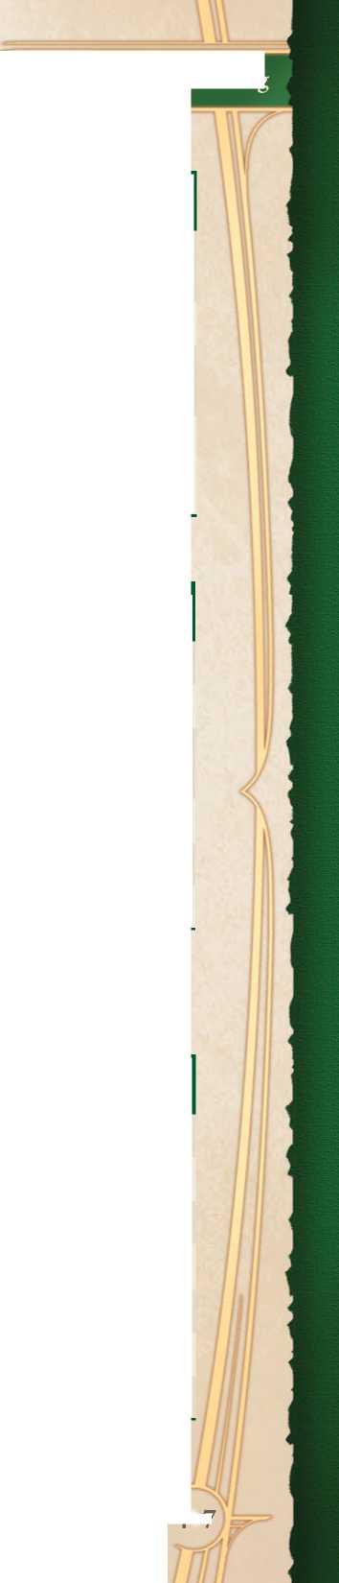

***Quality.*** The quality of an item affects the time, cost, and difficulty of crafting it. Items of fine quality or masterwork quality also offer special benefits. A fine item also costs an addi­tional 25 gold to produce, and a masterwork item 125 gold.

***Engineering.*** The Craft downtime activity can also be used for buildings, engineering devices, and other projects. Each check requires a week of work and access to an amount of gold worth of materials. The DC and materials cost are deter­mined by the project’s complexity. The scope of the project determines how many checks are required to complete it.

TABLE: CRAFTING TIME

|  |  |
| --- | --- |
| **ITEM** | **CRAFT TIME** |
| Light weapon | 2 per week |
| Medium weapon | 1 week |
| Heavy weapon | 2 weeks |
| Ammunition | 50 per week |
| Light armor | 1 week |
| Medium armor | 2 weeks |
| Heavy armor | 4 weeks |
| Tool or equipment | 2 per week |

Gather Information

The Gather Information activity is used to uncover secure or secret information about individuals, events, organizations, or other things that still exist within living memory. Gather Information is typically done by word-of-mouth on the street or in taverns.

The character specifies a particular individual, event, organization, or place from which they wish to learn more and specify a specific piece of information that they’re seeking to learn, making an Investigation check. The time, DC, and costs are included below.

On a success, the character learns what they are looking for along with a point of Key Knowledge. Success by 5 or more grants an additional fact or useful piece of information and an additional point of Key Knowledge. Failure means that the char­acter learns nothing, and on a failure by 5 or more they instead learn an incorrect piece of information that could lead them astray or cause some trouble.

***Key Knowledge.*** Key Knowledge represents clues, secrets, or other insights into a particular location, individual, or event. Each point of Key Knowledge is specific to an individual, creature, or location. These points may be spent to gain advantage on an attack roll or ability check made in relation to the subject.

At the Narrator’s discretion, these points can also be spent to introduce a small fact to the story. Perhaps a character learns of a friendly bartender

TABLE: GATHER INFORMATION

|  |  |  |  |  |
| --- | --- | --- | --- | --- |
| **OBSCURITY** | **DC** | **TIME** | **COST** | **EXAMPLES** |
| Uncommon | 10 | 1 week | 10 gp | The bar where a local crime boss conducts business, where a local noble likes to drink |
| Esoteric | 15 | 2 weeks | 25 gp | The name of the best fence in a particular city, where to go to get illicit magic ingredients |
| Hidden | 20 | 3 weeks | 100 gp | The location of the duke’s secret prison, the name of a dragon’s agent in a city |
| Secret | 25 | 5 weeks | 500+ gp | The identity of the leader of a guild of assassins, what the king keeps in the secret room below his chambers |

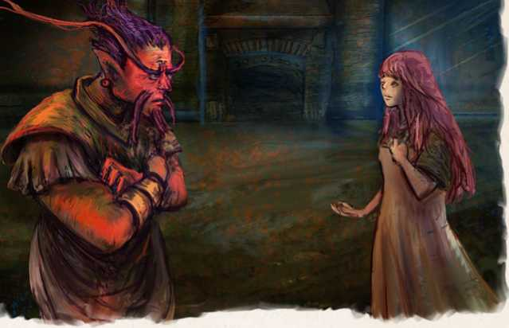

Chapter 7: Adventuring

• Make one additional saving throw against one  
disease or poison currently affecting them.

If a character is tended to by someone with a healer’s satchel, they have advantage on the above checks.

Religious Devotion

Religious Devotion allows a character to engage in acts of piety in an attempt to appease the gods and

while Gathering Information about the next town or discovers a potentially safe cavern while Researching the dungeon they plan to enter.

***Limitations.*** The Narrator may decide that there is simply no way that a piece of informa­tion can be gleaned by the Gather Information activity. In this case, the Narrator should inform the player before attempting the check.

Recovery

earn their favor. In order to engage in this downtime activity, a character must have access to a shrine, temple, or other sacred site and spend the required gold on sacred offerings to make a Nature or Religion check against a DC from Table: Religious Devotion. On a success, the character gains 1 point of favor, plus 1 additional point of favor for every 5 points their result exceeds the DC.

***Favor.*** A point of favor can be spent to repre­sent a minor but helpful boon that aligns with a deity’s portfolio. A point of favor from a war god might allow a character to find a weapon after they’ve been disarmed, while a point of favor from a nature god might make it easier to find a safe place to camp.

The specific details are left up to the Narrator, but in general, this should represent advantage on a roll, the discovery of a small but useful item, or a helpful chance encounter. For 2 favor points, the Narrator may allow a character to benefit from the effects of a lst-level spell that aligns with a deity’s portfolio. Narrators are free to come up with other uses.

| **SIMILARITY** | **DC** | **OFFERING** | **DESCRIPTION** |
| --- | --- | --- | --- |
| Strongly Aligned | 10 | 10 gp | The characters’ personal ethos and actions closely mirror the deity’s philosophy and teachings. |
| Aligned | 15 | 25 gp | The characters’ personal ethos and actions are generally similar to the deity’s philosophy and teachings. |
| Neutral | 20 | 50 gp | The character’s personal ethos and actions do not align with or oppose the deity they are beseeching. |
| Opposed | 25 | 100 gp | The character’s personal ethos and actions are generally counter to the deity’s philosophy and teachings. |
| Strongly Opposed | 30 | 500 gp | The characters’ personal ethos and actions run directly counter to |

TABLE: RELIGIOUS DEVOTION

PHILOSOPHICAL

the deity’s philosophy and teachings.

*The Narrator may allow specific actions by the character to reduce or eliminate this cost.

If a character acts against the interests or philosophy of a deity during an adventure, any points of favor are immediately lost.

Research

Research is used to uncover obscure information about individuals, events, organizations, or other things that have faded beyond living memory but still exist in recorded history. Alternatively, Research can be used to find facts or information contained within bureaucratic records.

In order to conduct the Research activity, a char­acter must have access to a library or libraries that might conceivably contain the information that they are searching for — a noble villa’s private library might contain original ownership records, but is unlikely to contain information regarding alien interlopers from the last age. The character makes an Arcana or History check (determined by the topic of Research) against the DC listed on Table: Research, taking an appropriate amount of time and spending the indicated amount of gold.

On a success, they learn what they are looking for along with a point of Key Knowledge (see Gather Information). Success by 5 or more grants an additional fact or useful piece of information and an additional point of Key Knowledge. Failure means that the character learns nothing, and on a failure by 5 or more they instead learn an incorrect piece of information that could lead them astray or cause some trouble.

The cost of research is reflective of bribes, library fees, and other related expenses. At the Narrator’s discretion, a character may dispense with these if they already have access to a library that may contain the information.

Spellcraft

This downtime activity allows spellcasters to create rare spells by refining their knowledge. Pick a common version of a spell that the char­acter knows and choose one modification from the modifications table. Alternatively, with the Narrator’s permission a character may choose one rare spell from Chapter 11: Spellcasting provided it is of a level they can cast.

The character makes an ability check using their spellcasting ability and Arcana (sorcerer, warlock, wizard), Nature (druid), Performance (bard), or Religion (cleric, herald). The DC of the check is based on the spell level as per Table: Rare Spell Crafting and is increased by the desired modification.

Each check requires 1 week and the amount of indicated materials. A character requires a number of successful Research weeks as listed on Table: Rare Spell Crafting. If a character succeeds the check by 5 or more, that week counts as 2 weeks for the purposes of completion. On a failure, the character makes no progress that week and the materials are consumed, and on a failure by 5 or more the materials are consumed and a week of progress is lost. The rare spell is finished when the final check succeeds.

TABLE: RESEARCH

|  |  |  |  |  |
| --- | --- | --- | --- | --- |
| **OBSCURITY** | **DC** | **TIME** | **COST\*** | **EXAMPLES** |
| Uncommon | 10 | 1 week | 10 gp | The original name of a particular village |
| Esoteric | 15 | 2 weeks | 25 gP | The original owner of a piece of land or business, the location of an ancient tomb |
| Hidden | 20 | 3 weeks | 100 gp | The true history of the founding of a dynasty, the real lineage of the local ruler |
| Secret | 25 | 5 weeks | 500+ gp | The name of a fiend, the location of a city destroyed by the gods in the last age |

In addition to crafting rare spells, it is possible to create entirely new spells. This process typically requires years of work and often represents the pinnacle of a spellcaster’s career. If a character wishes to create their own spell, It should require at least 2 months per spell level and 500 gold per spell level each week. DCs for such checks and the other specifics are determined by the Narrator, using the rules for crafting rare spells as a guideline.

In order to invent a rare spell, a character must have access to the appropriate type of library. Wizards and sorcerers require a collection of arcane tomes. Clerics and heralds must have access to books of esoteric lore and theological texts. Druids need a sacred place of nature untouched by civilization. Bards utilize folios of magical compositions. Warlocks require texts of fiendish law.

Creating rare spells should be a collaboration with the Narrator. As always, the Narrator must approve any new rare spell. When in doubt, use preexisting rare spell effects for inspiration.

**Chapter 7: Adventuring**

|  |  |  |
| --- | --- | --- |
| **MODIFICATION** | **DC MODIFIER** | **EFFECT** |
| Altered Effect | +0 | The spell’s primary effect is changed. This can be used to add or alter a spells damage type, affect what the spell targets, or otherwise modifies its core effect. Examples include an *invisibility* spell that targets objects instead of creatures, a *fireball* that deals cold damage, or a *lightning bolt* that has a cone area. |
| Lingering Effect | +1 | This spell has a secondary effect that occurs after the spell has ended. Examples include a *fireball* that causes the target to take ongoing fire damage or a *slow* spell that leaves a target fatigued after it’s duration has ended. |
| Additional Effect | +2 | An additional effect is added to the spell’s primary function. Examples include an *ice storm* that freezes a target in place for the duration. |
| Additional Target | +2 | This spell has the means to target additional creatures. Examples include a paralyzing effect that spreads by touch or a *suggestion* to new targets through conversation. |

TABLE: RARE SPELL MODIFICATIONS

|  |  |  |  |
| --- | --- | --- | --- |
| **SPELL LEVEL** | **DC** | **COST PER WEEK** | **SUCCESSFUL RESEARCH WEEKS** |
| 1st | 15 | 100 gp | 2 |
| 2nd | 16 | 150 gP | 3 |
| 3rd | 17 | 200 gP | 4 |
| 4th | 18 | 300 gp | 5 |
| 5th | 19 | 500 gP | 6 |
| 6th | 20 | 1,000 gp | 7 |
| 7th | 21 | 1,500 gp | 8 |
| 8th | 22 | 3,000 gp | 9 |
| 9th | 23 | 5,000 gp | 10 |

TABLE: RARE SPELL CRAFTING

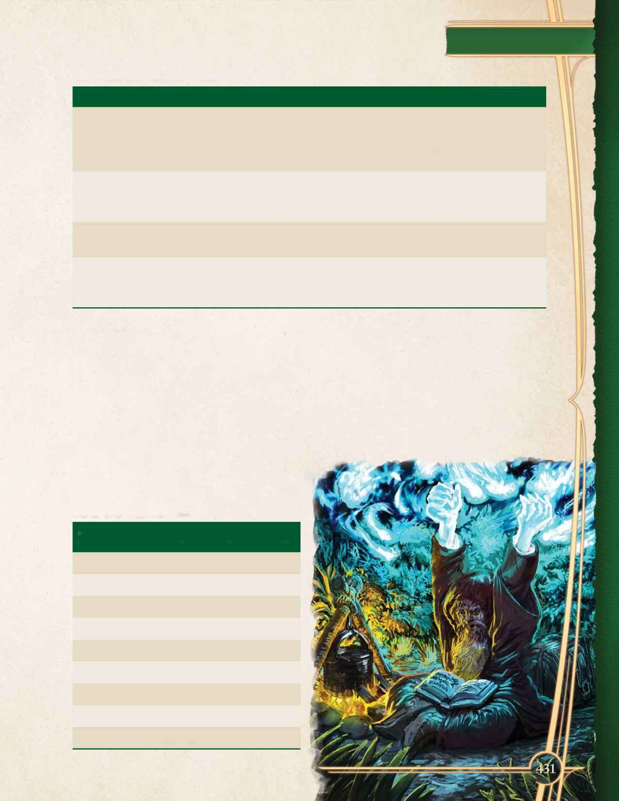

Train

The Train activity allows a character to learn a new weapon, language, skill, or tool proficiency, or it can be used to swap a class feature or feat that they learned previously.

***Language or Tool.*** Learning a new language or tool proficiency requires a character spend a number of months equal to 12 - their Intelligence modifier and pay 50 gold pieces per month to retain a tutor. If a character does not wish to pay for or does not have access to a tutor, they must have another reliable means of learning and the time required is doubled. At the end of this period, the character acquires the proficiency.

***Weapon.*** Learning a new weapon proficiency requires a character spend a number of months equal to 6 - their Strength or Dexterity modifier (whichever is highest) training and pay 50 gold pieces per month to retain a tutor. At the end of this time period, the character acquires the weapon proficiency.

***Relearning.*** A character may also relearn class features. This activity does not require spending any gold. The time required is 1 week to change a feature gained at 1st-5th level, 2 weeks to change a feature gained at 6th-10th level, 3 weeks to change a feature gained at 11th-15th level, and 4 weeks to change a feature gained at 15th-20th level. This activity cannot be used to swap out spells that have been entered into a spellbook.

***Feat.*** To swap a feat gained through leveling to another feat, a character may spend a number of months equal to 8 - their proficiency bonus and pay 50 gold pieces each month to acquire practice materials and advice from experts in the feat they are learning.

***Archetype.*** A character can change to a different archetype for their class by spending 12 weeks mastering the new archetype, at which point they are able to select it. When they do, any class features gained from their previous arche­type are lost and replaced by the class features of their new archetype. Changing from one class to another requires the use of powerful reality­altering magic (like the *wish* spell or the direct intervention of a deity).

Work

A character can use the Work activity to pay their cost of living expenses and earn some coin between adventures. Work is broken down into two categories.

***Legal Work.*** Legal work allows a character to practice a trade or profession without fear of consequence. The character selects a tool proficiency or skill approved by the Narrator and makes an ability check, consulting Table: Work to determine the lifestyle their profits support and the extra gold earned. On a result of 5 or less, a character earns nothing, supports no lifestyle, and has disadvantage on the next Work check that they make using the same skill or tool.

***Illegal Work.*** Illegal work allows a character to sustain themselves and make some coin by engaging in petty crime. First, a character selects the type of crime that they would like to engage in and selects an appropriate skill or ability check approved by the Narrator. They then select the difficulty of criminal activities as per Table: Work.

On a failed check, a character receives no earnings and must cover the cost of their lifestyle themselves. If they fail by 5 or more, the character must lay low and cannot take a downtime activity for the following week, and on a failure by 10 or more they are caught and suffer consequences or complications determined by the Narrator.

TABLE: WORK

|  |  |  |  |
| --- | --- | --- | --- |
| **DIFFICULTY** | **DC** | **LIFESTYLE** | **EARNINGS** |
| Easy | 10 | poor | 1d6 |
| Average | 15 | moderate | 3d6 |
| Hard | 20 | rich | 6d6 |
| Very Hard | 25 | rich | 10d6 |

Prestige Rating

A character’s Prestige rating represents how prominent they are, either as an ally or enemy, and can influence how easy it is for the character to call in favors from their allies, or determine how much effort their enemies will put into defeating them. Most Prestige ratings range from 0 to 6, although some deities and extraplanar beings may have higher ratings.

Player characters start with a Prestige rating of 1. Each time a character enters a new tier of play at 5th, 11th, and 17th level their Prestige rating increases by 1. Additionally, characters may gain Prestige when acquiring a stronghold, and the Narrator may award Prestige when they accom­plish great deeds during play. Finally, some class features may grant Prestige bonuses.

Additionally, Prestige determines how many followers a character can have at any one time. This number is equal to the character’s Prestige rating.

***Prestige Center.*** A character’s Prestige rating distinguishes how widely known they are. If they travel beyond their home, the character may find that people do not know who they are. Prestige applies in an area whose size is determined by a character’s Prestige score, starting from as small as a village to as large as an entire world. When creating a character, the player should work with the Narrator to determine where their Prestige is centered from. Often this will be the starting area of a campaign.

***Prestige Check.*** To determine whether some­body has heard of a character, or to call in a favor (see below), the character makes a Prestige check by rolling 1d20 and adding their Prestige rating. The DC of a Prestige check is equal to 12 + double the tier of the region the character is in (or when extremely far from their Prestige Center, triple the tier). When outside the area described by their Prestige rating, the character has disadvantage.

For example, Zidi Wheatling, the “Halfling Titan”, has a Prestige rating of 5. She is known across the county for her great strength, and stories of how she beat a minotaur in an arm-wrestling match have become a regional legend. She has traveled all the way to the country’s capital (a tier 2 region) and seeks an audience with a wealthy noble. Zidi rolls a Prestige check with disadvantage, adding 5 to the roll (from her Prestige rating) against DC 16. Unfortunately the result is an 11 — the noble has not heard of her and will not grant her an audi­ence. Zidi has to find some other way to attract their attention!

In the *Zeitgeist: The Gears of Revolution* adventure path, instead of tracking Prestige geographically, the Narrator tracks the party’s Prestige with five groups:

* Flint. The citizens of the city of Flint.
* Risur. The Royal Homeland Constabulary, and the greater Risuri government and military.
* The Unseen Court. The lords of the fey who rule in rhe I Dreaming.
* Criminal. A criminal group, the identity of which is secret at the start of the campaign.
* Philosophical. An ideological group, the identity of which is secret at the start of the campaign.

The *Gears of Revolution* adventure path is known for its plots, politics, and intrigue, and is an example of a setting where multiple Prestige tracks are required. *Zeitgeist* lists a range of setting-specific ways that Prestige can be used, from requisitioning equipment to calling in political favors. However, most campaigns will only use one.

TABLE: PRESTIGE RATING

|  |  |  |  |
| --- | --- | --- | --- |
| **RATING** | **IS WELL-KNOWN ACROSS** | **CAN GET AN AUDIENCE WITH** | **NOTORIETY** |
| 0 | Unknown | Nobody | The character is viewed with disdain, as a buffoon or pariah. People do not take them seriously. |
| 1 | Local | Shopkeep | The character is relatively unknown, but some local folks know them. |
| 2 | Village | Guard captain | The character has done a few noteworthy things, but most people don’t know them or assume they won’t do anything else interesting. |
| 3 | Town | Mayor | The character has become known across town, or across a district of a city. |
| 4 | City | Minor noble | The character is known across an entire city, or a single town plus its immediate environs. |
| 5 | Region | Noble | The character has distinguished themself across the region, and most influential people know about their actions and talents. |
| 6 | Country | Powerful noble | The character is known all across the land. People pay close attention to them, either viewing them as a powerful ally or a dangerous enemy. |
| 7 | Continent | Monarch | The character is well known by those in more than one country. Monarchs and important rulers typically have this level of Prestige. |
| 8 | World | Emperor | The character is one of the most famous people in the world, known well to monarchs and powerful figures. A lot of resources are devoted to either helping them out or taking them down. |
| 9 | Plane | Minor deity | The character is known not just on this world, but on other worlds on the same plane of existence. They might have saved or threatened the entire world. |
| 10 | Multiverse | Greater deity | The character is known not just across the world, but by powerful beings on other planes. |
| 11 | Multiverse | Greater deity | When the character seeks the audience of powerful beings like gods they are noticed. |
| 12 | Multiverse | Greater deity | When the character seeks the audience of powerful beings like gods they are answered. |
| 13 | Multiverse | Pantheon | When the character seeks the audience of powerful beings like gods they are answered in a timely manner. |
| 14+ | Divine | Anybody | This level of Prestige is usually the province of deities and other powerful extraplanar beings. The character is widely known on multiple worlds or planes. |

Optional Rule:

Most fantasy adventurers are free agents with no boss but themselves, usually out on the edge of civilization with few allies they can call on in a pinch. Over the course of a campaign however, player characters may want to call in favors from a friendly baroness, the local police, or other power groups. Prestige provides a quick guideline of how much clout the party has, whether they’re calling in a mage to perform a ritual beyond their ken, or trying to get their hands

Calling In Favors

In addition to acting as a handy track of a character’s noto­riety, Prestige can be used to call in favors. Use the following guidelines to determine the level of a favor. Calling in a favor normally takes 1d6 hours and requires a Prestige check. The party as a whole can call in one favor per day. As a default, favors can get people to help for up to half an hour. Any task that requires a few hours or more increases the level by 1, or if for a day or more by 2.

The favor ratings below are just guidelines. The Narrator can impose modifiers at their discretion, or state that certain favors are impossible.

on a rare battle wand before assaulting a criminal stronghold.

Example Favors

Here are some sample favors.

*Level 0 (Unknown).* Urchins to watch a street. A scribe to look through documents or handle paperwork. A carriage-driver to provide discreet passage around a district.

*Level 1 (Local).* Audience with the guard captain. A ferry-man to give discreet passage around the city. A craftsman to make a custom mundane item (the char­acter pays the normal price). A minor noble to bend the rules. A bard to tell a story.

*Level 2 (Village).* Audience with the mayor. A docker to create a distraction that might get them into trouble. A bard to spread a false tale that could have serious consequences. A major noble agreeing to converse for a lew minutes.

*Level 3 (Town).* Audience with a minor noble. A gang of bandits to commit some crimes. A small group of concerned citizens to rally and protest somewhere.

*Level 4 (City).* A large crowd of protesters to block off a whole building or street. A temple’s acolytes to come out and use their skills for the common people. A ship captain to smuggle something.

*Level 5 (Region).* Audience with a powerful noble. A noble to take a stand for something that might cost them their position. A city-wide search for a missing person. A local celebrity to put on a private show.

*Level 6 (Country).* Audience with a monarch. A city­wide protest. A call for all citizens to take arms against a threat.

*Level 7 (Continent).* A national uprising against a tyrannical monarch. Royal pardon for a heinous crime. Borrow an artifact.

*Level 8 (World).* Coronation as a monarch.

*Level 9 (Plane).* Audience with a deity.

*Level 10 (Multiverse).* Audience with a pantheon.